**Федеральное государственное образовательное бюджетное учреждение**

**высшего образования**

**Финансовый университет при Правительстве Российской Федерации**

**КОЛЛЕДЖ ИНФОРМАТИКИ И ПРОГРАММИРОВАНИЯ**

**Отчет по**

**Лабораторной работе №8**

**Студента: Рагимов Владислав**

**Дисциплина /Профессиональный модуль: Разработка программных модулей**

**Группа: 4ИСИП-619**

**Преподаватель**

**Сибирев Иван Валерьевич /____________/**

**Оценка за работу:**

**2022г**

**Цель работы:**

Освоить методы переноса и генерации скриптов базы данных

**Ход работы:**

Для Базы данных из лабораторной работы 2 реализовать перенос

базы данных через механизм резервного копирования, сгенерировать

скрипт создания базы данных.

1 Резервное копирование

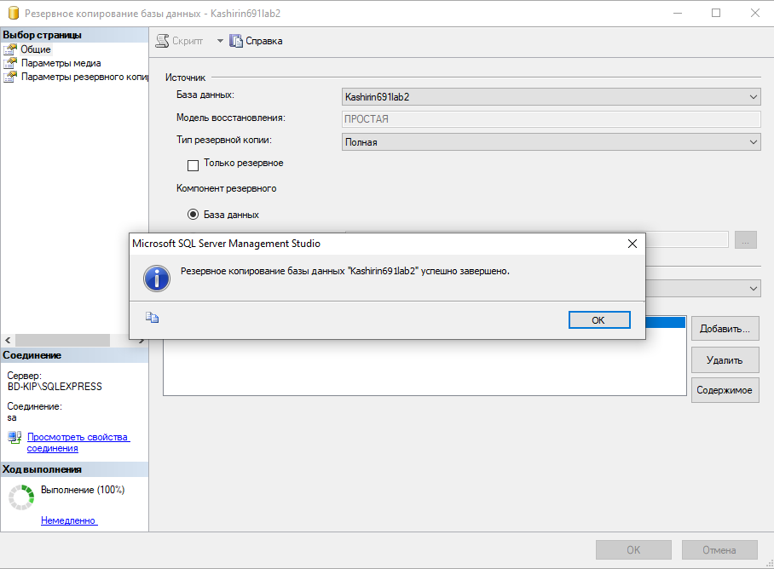

2 Создаем скрипт бд

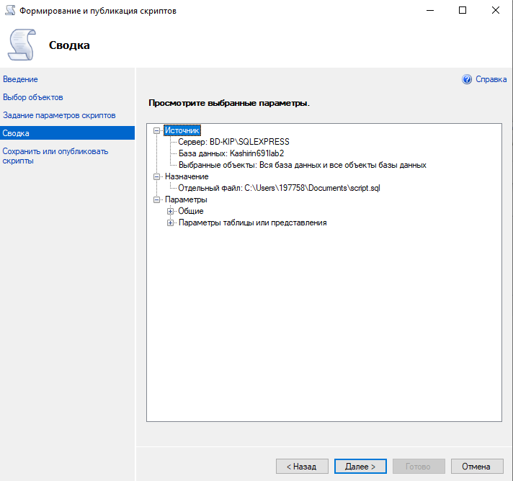

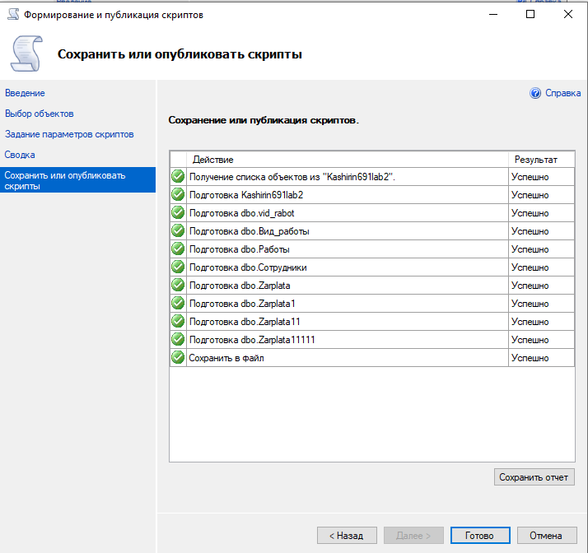

USE [master]

GO

/****** Object: Database [Ragimov691lab2] Script Date: 27.10.2022 12:36:02 ******/

CREATE DATABASE [Ragimov691lab2]

CONTAINMENT = NONE

ON PRIMARY

( NAME = N'Ragimov691lab2', FILENAME = N'C:\Program Files\Microsoft SQL Server\MSSQL12.SQLEXPRESS\MSSQL\DATA\Ragimov691lab2.mdf' , SIZE = 5120KB , MAXSIZE = UNLIMITED, FILEGROWTH = 1024KB )

LOG ON

( NAME = N'Ragimov691lab2_log', FILENAME = N'C:\Program Files\Microsoft SQL Server\MSSQL12.SQLEXPRESS\MSSQL\DATA\Ragimov691lab2_log.ldf' , SIZE = 1024KB , MAXSIZE = 2048GB , FILEGROWTH = 10%)

GO

ALTER DATABASE [Ragimov691lab2] SET COMPATIBILITY_LEVEL = 120

GO

IF (1 = FULLTEXTSERVICEPROPERTY('IsFullTextInstalled'))

begin

EXEC [Ragimov691lab2].[dbo].[sp_fulltext_database] @action = 'enable'

end

GO

ALTER DATABASE [Ragimov691lab2] SET ANSI_NULL_DEFAULT OFF

GO

ALTER DATABASE [Ragimov691lab2] SET ANSI_NULLS OFF

GO

ALTER DATABASE [Ragimov691lab2] SET ANSI_PADDING OFF

GO

ALTER DATABASE [Ragimov691lab2] SET ANSI_WARNINGS OFF

GO

ALTER DATABASE [Ragimov691lab2] SET ARITHABORT OFF

GO

ALTER DATABASE [Ragimov691lab2] SET AUTO_CLOSE OFF

GO

ALTER DATABASE [Ragimov691lab2] SET AUTO_SHRINK OFF

GO

ALTER DATABASE [Ragimov691lab2] SET AUTO_UPDATE_STATISTICS ON

GO

ALTER DATABASE [Ragimov691lab2] SET CURSOR_CLOSE_ON_COMMIT OFF

GO

ALTER DATABASE [Ragimov691lab2] SET CURSOR_DEFAULT GLOBAL

GO

ALTER DATABASE [Ragimov691lab2] SET CONCAT_NULL_YIELDS_NULL OFF

GO

ALTER DATABASE [Ragimov691lab2] SET NUMERIC_ROUNDABORT OFF

GO

ALTER DATABASE [Ragimov691lab2] SET QUOTED_IDENTIFIER OFF

GO

ALTER DATABASE [Ragimov691lab2] SET RECURSIVE_TRIGGERS OFF

GO

ALTER DATABASE [Ragimov691lab2] SET DISABLE_BROKER

GO

ALTER DATABASE [Ragimov691lab2] SET AUTO_UPDATE_STATISTICS_ASYNC OFF

GO

ALTER DATABASE [Ragimov691lab2] SET DATE_CORRELATION_OPTIMIZATION OFF

GO

ALTER DATABASE [Ragimov691lab2] SET TRUSTWORTHY OFF

GO

ALTER DATABASE [Ragimov691lab2] SET ALLOW_SNAPSHOT_ISOLATION OFF

GO

ALTER DATABASE [Ragimov691lab2] SET PARAMETERIZATION SIMPLE

GO

ALTER DATABASE [Ragimov691lab2] SET READ_COMMITTED_SNAPSHOT OFF

GO

ALTER DATABASE [Ragimov691lab2] SET HONOR_BROKER_PRIORITY OFF

GO

ALTER DATABASE [Ragimov691lab2] SET RECOVERY SIMPLE

GO

ALTER DATABASE [Ragimov691lab2] SET MULTI_USER

GO

ALTER DATABASE [Ragimov691lab2] SET PAGE_VERIFY CHECKSUM

GO

ALTER DATABASE [Ragimov691lab2] SET DB_CHAINING OFF

GO

ALTER DATABASE [Ragimov691lab2] SET FILESTREAM( NON_TRANSACTED_ACCESS = OFF )

GO

ALTER DATABASE [Ragimov691lab2] SET TARGET_RECOVERY_TIME = 0 SECONDS

GO

ALTER DATABASE [Ragimov691lab2] SET DELAYED_DURABILITY = DISABLED

GO

USE [Ragimov691lab2]

GO

/****** Object: Table [dbo].[vid_rabot] Script Date: 27.10.2022 12:36:03 ******/

SET ANSI_NULLS ON

GO

SET QUOTED_IDENTIFIER ON

GO

SET ANSI_PADDING ON

GO

CREATE TABLE [dbo].[vid_rabot](

[ID_vida] [int] NOT NULL,

[opisanie1] [varchar](1) NULL,

[pay_for_work] [int] NULL,

UNIQUE NONCLUSTERED

(

[pay_for_work] ASC

)WITH (PAD_INDEX = OFF, STATISTICS_NORECOMPUTE = OFF, IGNORE_DUP_KEY = OFF, ALLOW_ROW_LOCKS = ON, ALLOW_PAGE_LOCKS = ON) ON [PRIMARY]

) ON [PRIMARY]

GO

SET ANSI_PADDING OFF

**Вывод:** Сделали бакап БД